Insert your name, centre number and candidate number into the header above.
Save this evidence document as evidence_ followed by your centre number_ candidate number. For example: evidence_ zz999_9999.doc
Screenshots or program listings must be copied into appropriate cells in the following tables.
Examiners must be able to read the contents including any screenshots without the use of a magnifying glass. Answers that are not readable or missing will not be awarded any marks.
Save this evidence document at regular intervals, for example, every 10 minutes.
Question 1
Part 1(a)
def ReadData():
arr = []
try:
with open("Data(2).txt", "r", encoding = "utf-8") as f:
for line in f:
arr.append(line.strip())
return arr
except FileNotFoundError:
print("File does not exist.")

Part 1(b)(i)
def FormatArray(arr):
res = ""
for i in range(len(arr)):
res += arr[i] + " "
print(res[:len(res) - 1])

Part 1(b)(ii)
def main():
a = ReadData()
FormatArray(a)

if __name__ == "__main__":
main()

Part 1(b)(iii)

Part 1(c)
def CompareStrings(a, b):
for i in range(min(len(a), len(b))):
if a[i] > b[i]:
return 2
elif b[i] > a[i]:
return 1

Part 1(d)(i)
def Bubble(arr):
flag = False
while not flag:
flag = True
for i in range(len(arr) - 1):
if CompareStrings(arr[i], arr[i + 1]) == 2:
flag = False
arr[i], arr[i + 1] = arr[i + 1], arr[i]
return arr

Part 1(d)(ii)
def main():
a = ReadData()
Bubble(a)
FormatArray(a)

if __name__ == "__main__":
main()

Part 1(d)(iii)

Question 2
Part 2(a)(i)
class Horse:
def __init__(self, n, m, p):
self.__Name = n #string
self.__MaxFenceHeight = m #integer
self.__PercentageSuccess = p #integer

Part 2(a)(ii)
def GetName(self):
return self.__Name
def GetMaxFenceHeight(self):
return self.__MaxFenceHeight

Part 2(b)(i)
Horses = [Horse("Beauty", 150, 72), Horse("Jet", 160, 65)]
for i in Horses:
print(i.GetName())

Part 2(b)(ii)

Part 2(c)(i)
class Fence:
def __init__(self, h, r):
self.__Height = h #integer
self.__Risk = r #integer
def GetHeight(self):
return self.__Height
def GetRisk(self):
return self.__Risk

Part 2(c)(ii)
def main():
Horses = [Horse("Beauty", 150, 72), Horse("Jet", 160, 65)]
for i in Horses:
print(i.GetName())
Course = []
h = 0
r = 0
for i in range(4):
h = 0
r = 0
while h < 70 or h > 180 or r < 1 or r > 5:
h = int(input("Enter height: "))
r = int(input("Enter risk: "))
if h < 70 or h > 180 or r < 1 or r > 5:
print("Height must between 70 and 180 and Risk must between 1 and 5.")
Course.append(Fence(h, r))

Part 2(d)
def Success(self, height, risk):
if height > self.__MaxFenceHeight:
return self.__PercentageSuccess * 0.2
else:
return self.__PercentageSuccess * (1 - 0.1 * (risk - 1))

Part 2(e)(i)
for i in range(2):
for j in range(4):
print(f"The horse {Horses[i].GetName()} at fence {j + 1} has a {Horses[i].Success(Course[j].GetHeight(), Course[j].GetRisk())} % chance of success")

Part 2(e)(ii)
for i in Horses:
total = 0
for j in Course:
total += i.Success(j.GetHeight(), j.GetRisk())
print(f"The horse {i.GetName()} has an average {total / len(Course)}% chance of jumping over all four fences.")

Part 2(e)(iii)
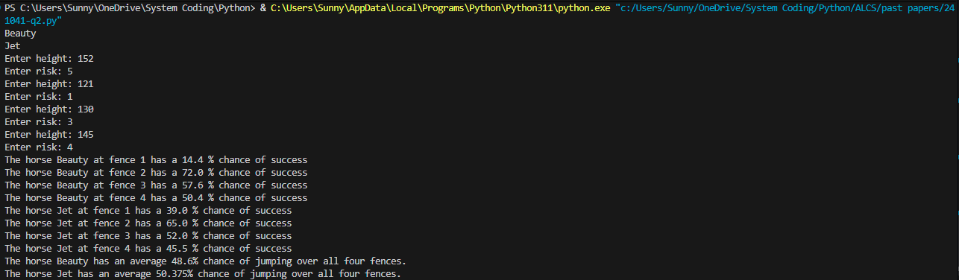

Question 3
Part 3(a)
global LinkedList, FirstEmpty, FirstNode
LinkedList = [[-1, j + 1] for j in range(20)]
LinkedList[19][1] = -1
FirstEmpty = 0
FirstNode = -1

Part 3(b)
def InsertData():
global LinkedList, FirstEmpty, FirstNode
for i in range(5):
a = int(input())
if FirstEmpty > 19 or or FirstEmpty < 0:
return
LinkedList[FirstEmpty][0] = a
tmp = LinkedList[FirstEmpty][1]
LinkedList[FirstEmpty][1] = FirstNode
FirstNode = FirstEmpty
FirstEmpty = tmp

Part 3(c)(i)
def OutputLinkedList():
global LinkedList, FirstNode
idx = FirstNode
while idx != -1:
print(LinkedList[idx][0])
idx = LinkedList[idx][1]

Part 3(c)(ii)
def main():
global LinkedList, FirstEmpty, FirstNode
InsertData()
OutputLinkedList()

if __name__ == "__main__":
main()

Part 3(c)(iii)
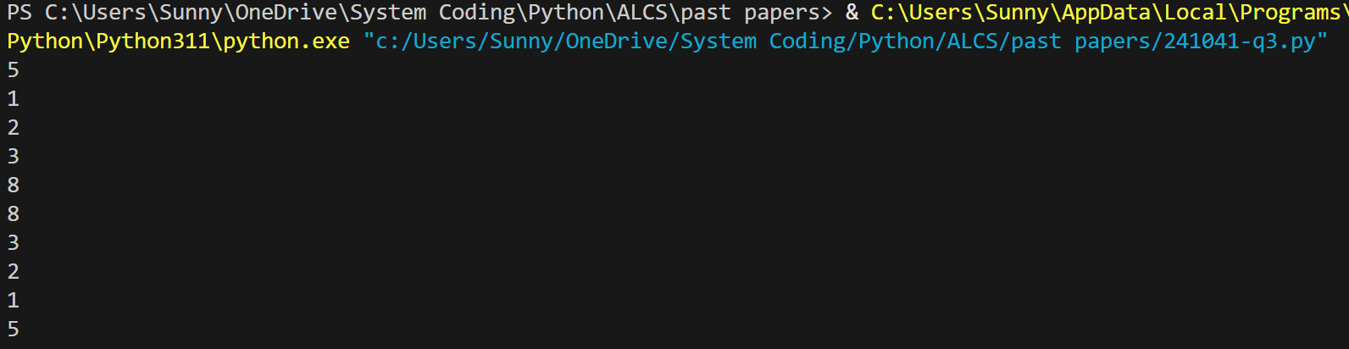

Part 3(d)(i)
def RemoveData(num):
global FirstEmpty, LinkedList, FirstNode
idx = FirstNode
tmp = idx
while idx != -1:
if LinkedList[idx][0] == num:
LinkedList[idx][0] = -1
if idx == FirstNode: FirstNode = LinkedList[idx][1]
LinkedList[tmp][1] = LinkedList[idx][1]
LinkedList[idx][1] = FirstEmpty
FirstEmpty = idx
else:
tmp = idx
idx = LinkedList[idx][1]

Part 3(d)(ii)
def main():
global LinkedList, FirstEmpty, FirstNode
InsertData()
OutputLinkedList()
RemoveData(5)
print("After")
OutputLinkedList()

if __name__ == "__main__":
main()

Part 3(d)(iii)
